**Market Segmentation Analysis of Electric Vehicles Market in India**

**Contributed by**

Ankit Kumar M

Ashish Parpolkar

Devam Tanwani

Chandana Hanumantha Rao

Date: 16/08/2024

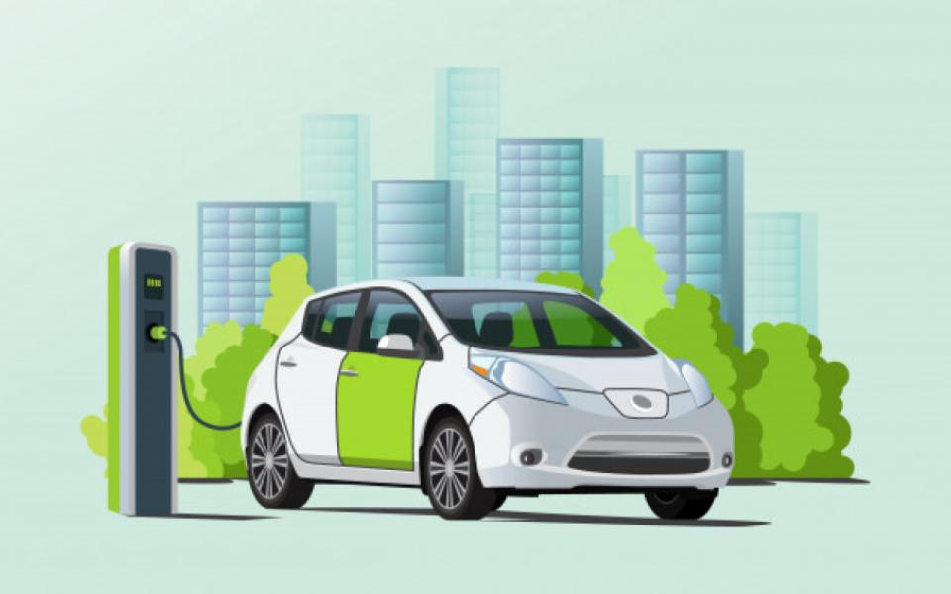

**Problem Statement:**

Road EVs include a large range of vehicles from electric two-wheelers, three-wheelers (rickshaws), cars and electric buses. In addition, plug-in electric vehicles can be classified into two types: battery electric vehicles (BEVs), and plug-in hybrid electric vehicles (PHEVs). BEVs have an electric motor in place of combustion engine and use electricity from the grid stored in batteries. Plug-in hybrid electric vehicles (PHEV) use batteries to power an electric motor and liquid fuel such as gasoline or diesel to power an internal combustion engine or other propulsion source. EVs can go beyond the above mentioned technology based classification, and can be classified on the basis of their attributes such as i) charging time, ii) driving range, and iii) the maximum load it can carry.

Of these attributes, the two most important characteristics of an electric vehicle of concern to the consumer are: -

1. Driving range (i.e. the maximum distance an EV can run when fully charged)

2. Charging time of batteries (i.e. the time required to fully charge the battery) and charging time depends on the input power characteristics (i.e. input voltage and current), battery type, and battery capacity.

In this analysis I have taken 2 dataset

**Dataset 1**

EV charging Stations: The dataset contains features like Zone, Power Capacity, Power Type, Time of Charging, City Name, payment mode, staff, unstaffed, station type, vehicle type etc. This dataset gives us brief analysis of

Charging stations distributions across different cities

Distribution of charging station types

Distribution of staffed v/s unstaffed charging stations

Distribution of charging station based on payment modes

Distribution of charging station based on power capacity

Time based analysis

Zone based analysis

Distribution of charging station based on supported vehicle types

**Dataset 2:**

EV market in India: This dataset has features like Brand, Model, AccelSec, Top Speed KmH,

Range_Km, Efficiency_WhKm, FastCharge_KmH, Rapid Charge, Powertrain, ‘Plug Type', Body Style, Segment, Seats, Price.

This dataset gives us a brief analysis of

Which car has high acceleration, Efficiency, Top speed, price etc.?

**Data Collection:**

The data collection has been collected from various sources, some data has been scrapped as well

Car wale website used for scrapping the data to get the information of EV cars in India

The others sources for data collection is Kaggle, Google data search, Data.gov.in.

For this study the reference links are:

<https://www.sciencedirect.com/topics/engineering/ev-charging-station>

<https://straitsresearch.com/report/indian-ev-market>

<https://www.data.gov.in/keywords/Electric>

**Data Pre Processing**

Data preprocessing is an important step in the data mining process. It refers to the cleaning, transforming, and integrating of data in order to make it ready for analysis.

In this project the process involved for analysis:

Data cleaning, Feature scaling, dealing with missing values and outliers, Label Encoding for converting categorical variables into numerical values

**Exploratory Data Analysis**

In Dataset 1 the EDA gives us insights on:

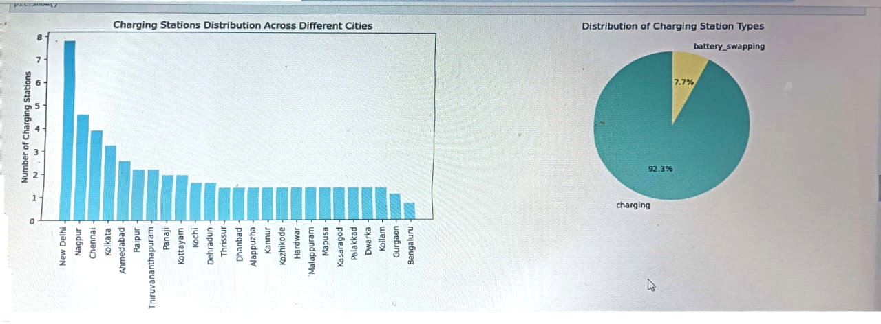

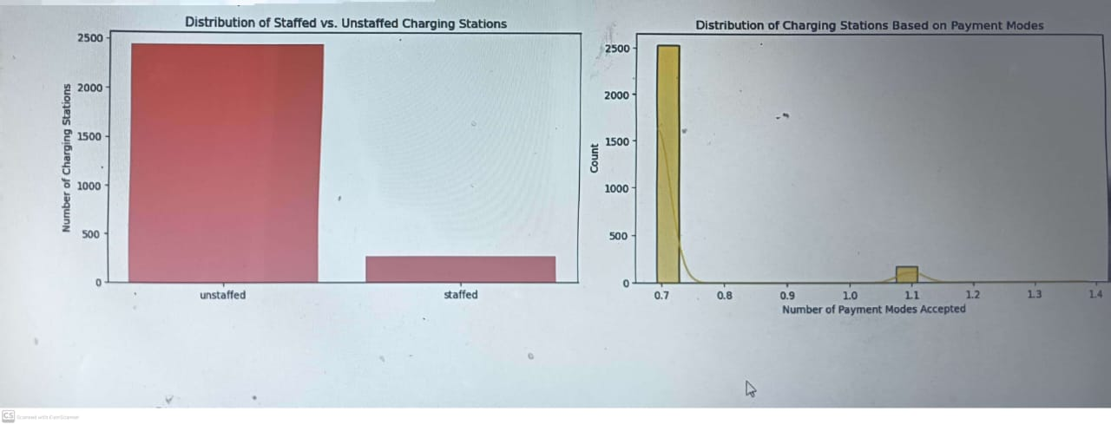

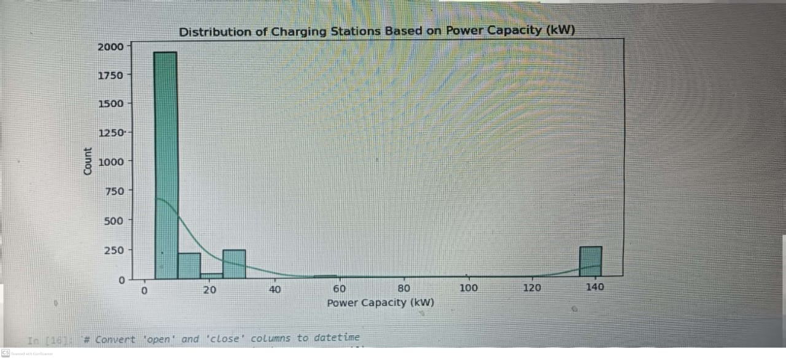

**Time based analysis**

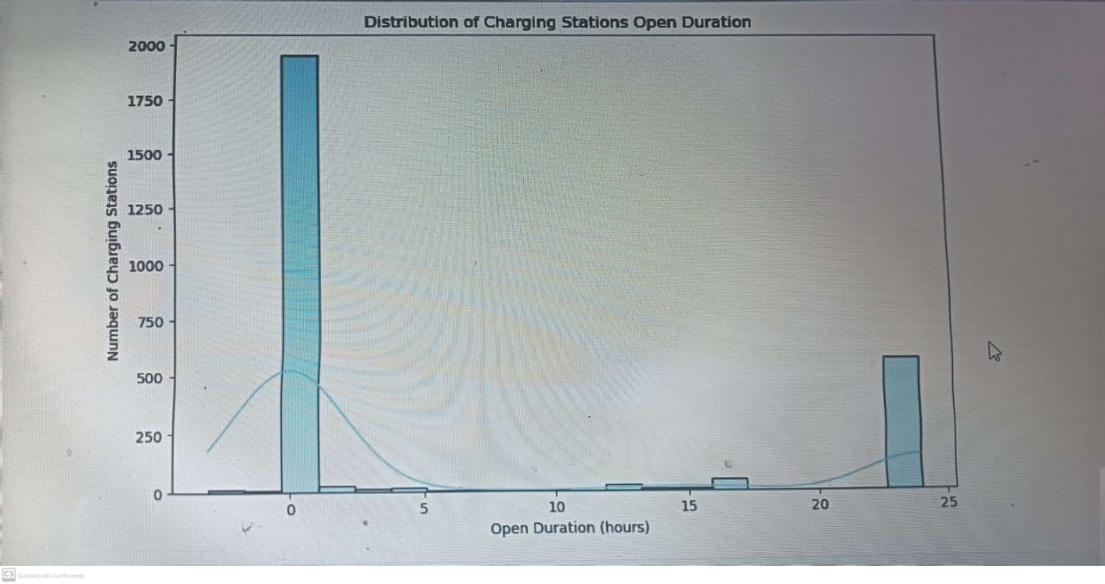

Open close duration

0 2024-01-14 2024-01-14 23:59:59 0 days 23:59:59

1 2024-01-14 2024-01-14 23:59:59 0 days 23:59:59

2 2024-01-14 2024-01-14 23:59:59 0 days 23:59:59

3 2024-01-14 2024-01-14 23:59:59 0 days 23:59:59

4 2024-01-14 2024-01-14 23:59:59 0 days 23:59:59

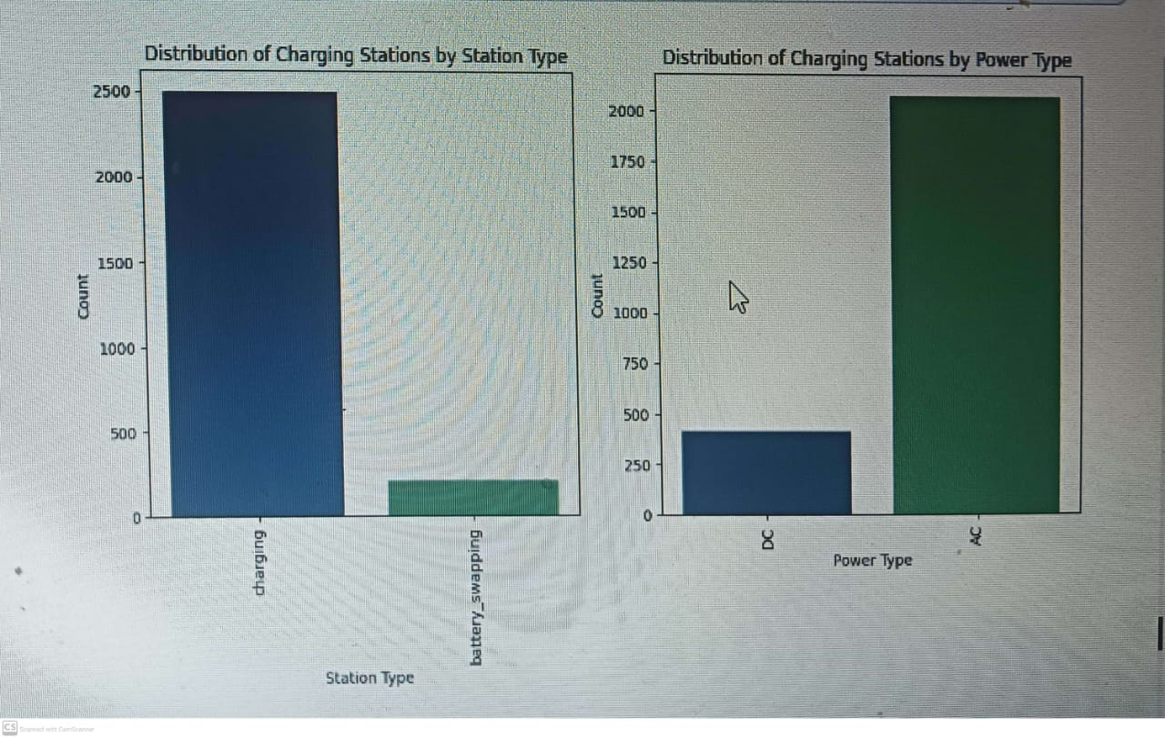

It is clear that charging is currently prominent and battery swapping although there is a lot of talk in the market about the ease of use of battery swapping but looks like it might take some more time for infrastructure to be ready for that.

**Capacity Analysis**

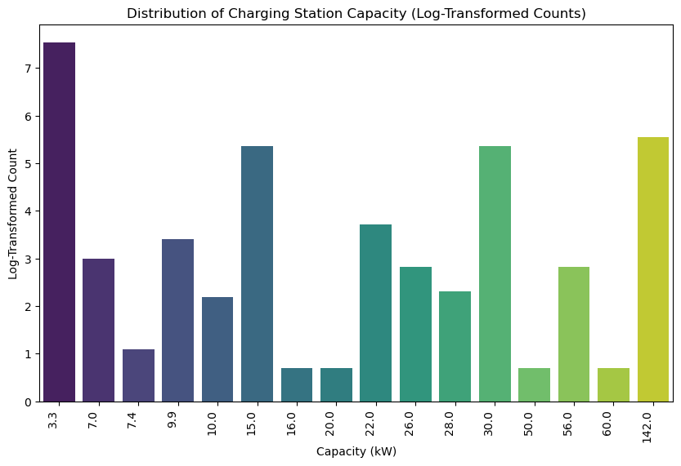

**Charging Station v/s Vehicle Type**

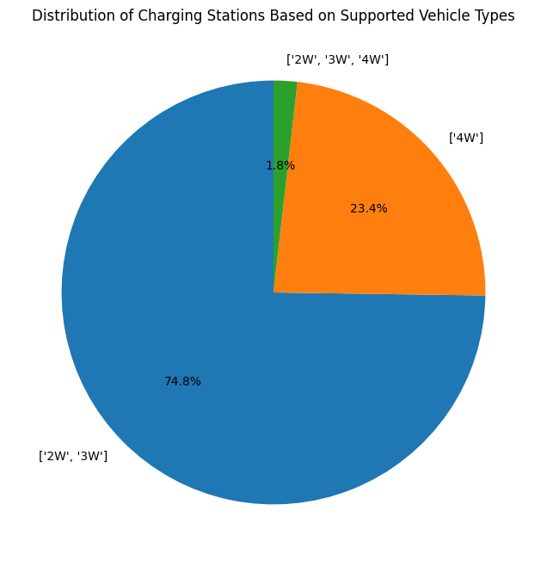

Charging station with only '4W' facility are very less in number compared to 2W and 3W. One inference that we can draw is that 4W are new set of vehicle types and infrastructure for these types are under development and possibly many of 2W and 3W stations will eventually have facility for 4W as well.

**Zone Wise Analysis**

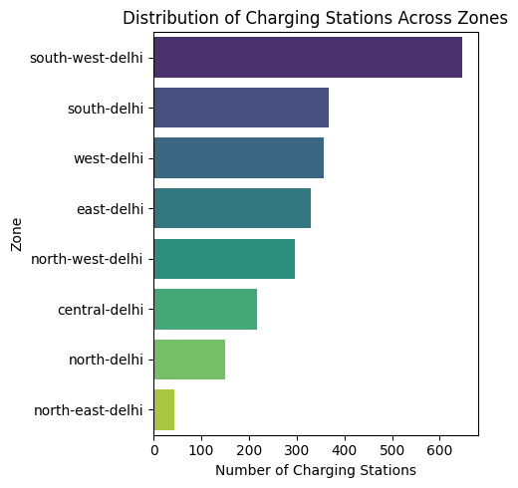

**EDA of Dataset 2**

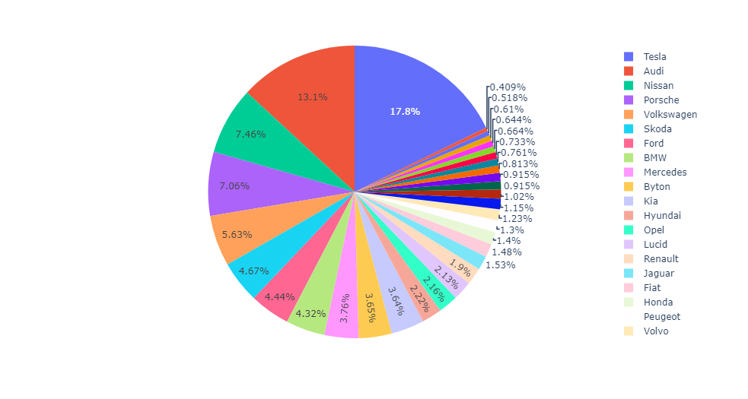

Brand Tesla has highest Price

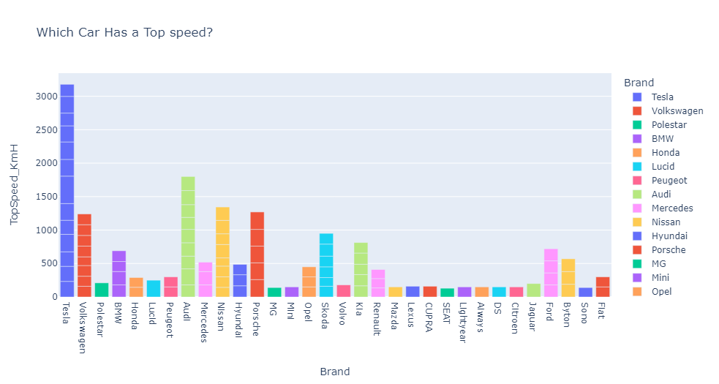

Brand Tesla has highest speed

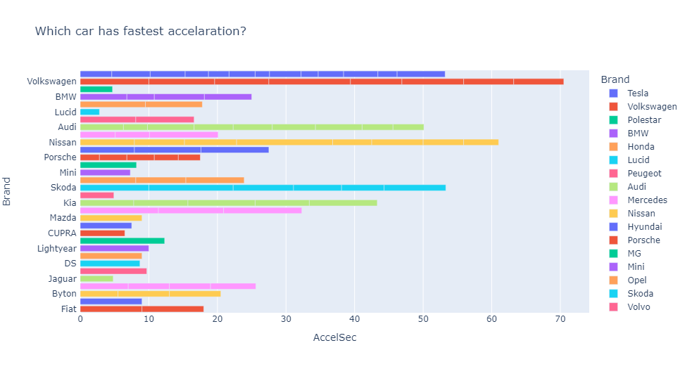

Brand Volkswagen has fastest acceleration

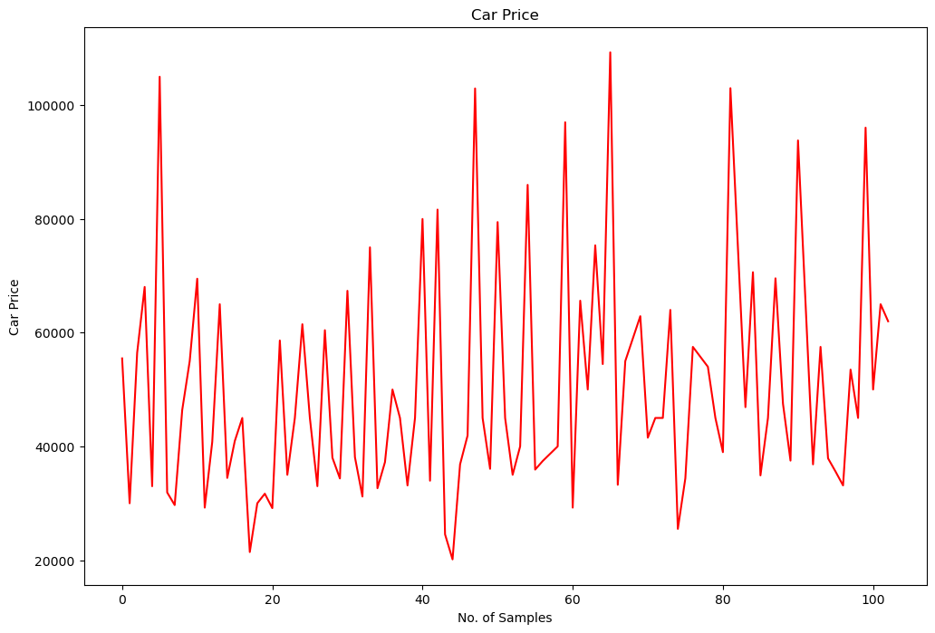

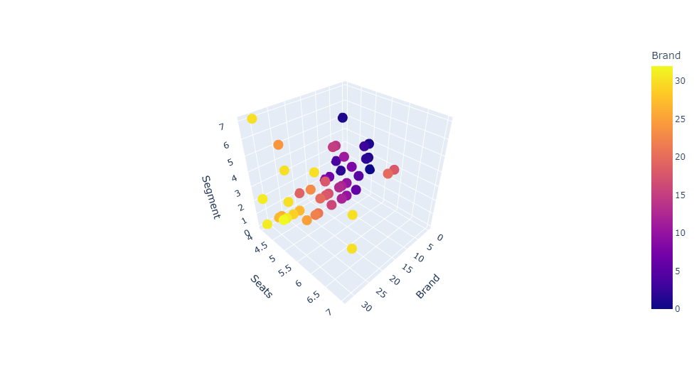

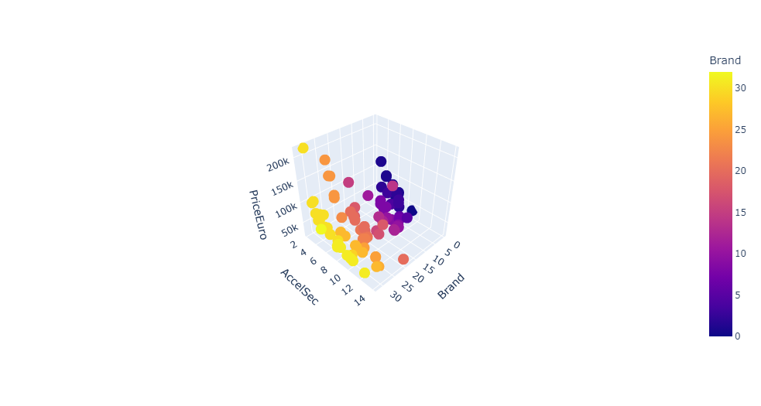

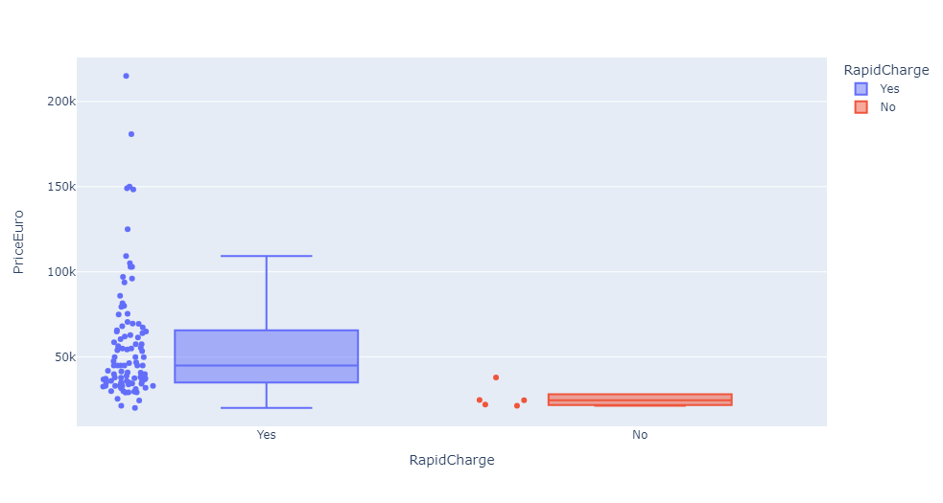

The segmentation technique is used to gain the insights on the various features listed above.

**Segment Extraction**

By vehicle type, the market is segmented into passenger cars and commercial vehicles.

By charger type, the market is segmented into AC charging stations and DC charging stations. By charging ownership type, the market is segmented into public and private.

For the segmentation analysis k means clustering algorithm is chosen

K means clustering, assigns data points to one of the K clusters depending on their distance from the center of the clusters. It starts by randomly assigning the clusters centroid in the space. Then each data point assign to one of the cluster based on its distance from centroid of the cluster. After assigning each point to one of the cluster, new cluster centroids are assigned. This process runs iteratively until it finds good cluster. In the analysis we assume that number of cluster is given in advanced and we have to put points in one of the group.

In some cases, K is not clearly defined, and we have to think about the optimal number of K. K Means clustering performs best data is well separated. When data points overlapped this clustering is not suitable. K Means is faster as compare to other clustering technique. It provides strong coupling between the data points. K Means cluster do not provide clear information regarding the quality of clusters. Different initial assignment of cluster centroid may lead to different clusters. Also, K Means algorithm is sensitive to noise. It may have stuck in local minima.

The goal of clustering is to divide the population or[set](https://www.geeksforgeeks.org/set-in-cpp-stl/) of data points into a number of groups so that the data points within each group are more [comparable](https://www.geeksforgeeks.org/comparable-vs-comparator-in-java/) to one another and different from the data points within the other groups. It is essentially a grouping of things based on how similar and different they are to one another.

Finding the ideal number of groups to divide the data into is a basic stage in any unsupervised algorithm. One of the most common techniques for figuring out this ideal value of k is the elbow approach.

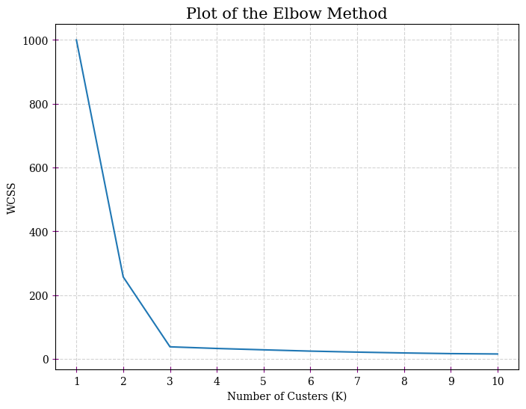

The segments chosen for the analysis to get the optimal market segmentation are

AccelSec, TopSpeed_KmH, Efficiency_WhKm, FastCharge_KmH, Range_Km, Rapid Charge, Seats, Price, Powertrain.

**Market Mix Factors**

To analyze the 4Ps (Product, Price, Place and Promotion) of marketing mix influencing purchasing the electric vehicles in India.

The objectives of this study were to analyze:

1) The marketing mix components affecting consumers’ decision to buy battery electric vehicles; 2) The technology acceptance affecting the consumers’ decision to buy battery electric vehicles.

3) The consumers’ decision to buy battery electric vehicles

Marketing Mix is the set of controllable variables that the firm can use to influence the buyer’s response. The controllable variables to the 4 Ps (product, price, place and promotion). Each firm strives to build up such a composition of 4Ps, which can create highest level of consumer satisfaction and at the same time meet its organizational objectives. Thus, this mix is assembled keeping in mind the needs of target customers, and it varies from one organization to another depending upon its available resources and marketing objectives.

Product: Product refers to the goods and services offered by the organization. All these are purchased because they satisfy one or more of our needs. We are paying not for the tangible product but for the benefit it will provide. Product can be described as a bundle of benefits which a marketer offers to the consumer for a price. Product can also take the form of a service like an air travel, telecommunication, etc. Thus, the term product refers to goods and services offered by the organization for sale.

Price: Price is the amount charged for a product or services. It is the second most important element in the marketing mix. Many factors like demand for a product, cost involved, consumer’s ability to pay, prices charged by competitors for similar products, government restrictions etc., must be kept in mind while fixing the price. In fact, pricing is a very crucial decision area as it has its effect on demand for the product and on the profitability of the firm.

Place: Goods are produced to be sold to the consumers. They must be made available to the consumers at a place where they can conveniently make purchase. This involves a chain of individuals and institutions like distributors, wholesalers and retailers who constitute firm’s distribution network (also called a channel of distribution).

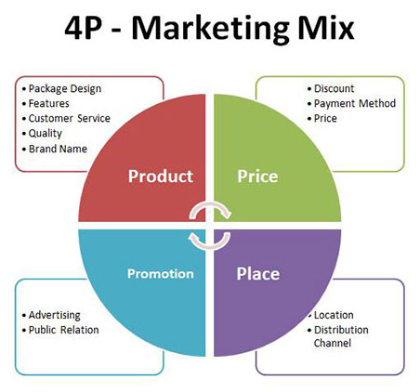

**The level of importance of product depends on**

Long life electric battery

Long life electric motor

Effectiveness of electric motor power

Cabin size

Luggage storage size

Safety system

Design and modernity

Fast electric charge

Multiple charging support

Driving mileage longer than fuel cars

**The level of importance of Price depends on**

Reasonable price with high quality

Maintenance cost

Car insurance fee

Cost of renew license plate

Price of accessories

Lifetime of battery

Selling price of used EV

**The level of importance of Place depends on**

One-stop service center

Clean and well decorated service center

Large service center

Many services center branches

Reserve new EV via online

Delivery service to doorstep

**The level of importance of Promotion depends on**

Cash discount

Free stuff

Car insurance

Glass coating

Wall box

Quality assurance for the battery

**Profiling market segments**

Some of the most popular market segmentation

**Geographic Segmentation**

Geographic segments divides the overall market based on geographic units such as countries,continents,zip code,states,trading blocks,cities,neighbourhood

**Demographic Segmentation**

Demographic Segmentation is dividing mass market into smaller segments and groups based on gender, income, age, occupation, life cycle stage, ethnicity, religion, and generation.

**Psychographic segmentation**

Inthe marketing world lifestyle oriented interests, activities, opinions are categorized as psychographic segmentation it helps to divide the potential buyers into different segmentation based on the personality characteristics, buying patterns, consumption opinion, opinion on social issues, leisure activities, hobbies and many other dimensions.

**Behavioral Segmentation**

Behavioral Segmentation divides buyers into groups based on the attitudes, product knowledge, product uses and other responses to the product.

**Targeting the Segments**

Based on the analysis the target segments can be narrowed down to EV’s having

Psychographic factors: such as comfort and value for money

Behavioral Factors such as good acceleration and price

Geographic factors such as the states/cities which are more market friendly

According to the analysis

South west Delhi, west Delhi, south Delhi has more charging stations

Volkswagen has highest acceleration

Tesla has highest price and Top Speed.

**EV Market Potential in India**

India’s electric vehicle (EV) market is currently valued at **$34.8 billion in 2024,**it's expected to zoom past **$120 billion by 2030**, reflecting a robust growth rate of 22.92% annually. The Indian government has introduced several initiatives and programs to promote the adoption of electric vehicles. Some of the key initiatives are as follows.

1. ***FAME II (Faster Adoption and Manufacturing of Hybrid and Electric Vehicles)***:

* Launched in 2019, this scheme provides incentives for the purchase of electric vehicles and supports the establishment of EV infrastructure. The Government has allocated a budget of 10,000 crores for this initiative.
* Despite the launch of FAME || in 2019, The Government revised the FAME II scheme to offer 50% more subsidy at ₹15,000 per kWh on electric bikes and scooters in India.
* The government has also allocated ₹1000 crores to set up charging stations for e-buses, one slow charging unit for each electric bus, and one fast charging station for ten electric buses.
* The central government of India also incentivizes 5 lakh three-wheelers, 7000 electric buses, and 35,000 four-wheelers.

1. **National Electric Mobility Mission Plan (NEMMP) 2020**

* NEMMP aims to enhance national energy security, mitigate adverse environmental impacts from road transport vehicles, and boost domestic manufacturing capabilities.
* India's NEMMP plan, launched in 2013, aims to boost electric vehicles for cleaner air and a more robust domestic EV industry.
* While initial targets weren't fully met, NEMMP's vision remains relevant. New initiatives like EMPS 2024 are building on this foundation. The *Electric Mobility Promotion Scheme (EMPS) 2024*, launched in April 2024, is a shorter-term initiative than NEMMP. It provides subsidies for electric two-wheeler and three-wheeler purchases to accelerate EV adoption in India further.
* The Electric Mobility Promotion Scheme (EMPS) 2024 offers tiered subsidies based on the type of electric vehicle:

1. **Electric Two-Wheelers:** Up to ₹10,000 per vehicle.
2. **Electric Three-Wheelers (E-Rickshaws & E-Carts):** Up to ₹25,000 per vehicle.
3. **Large Electric Three-Wheelers (L5 Category):** Up to ₹50,000 per vehicle.

* The *Electric Mobility Promotion Scheme (EMPS)* 2024 does not provide subsidies for electric cars in India. The program promotes the adoption of electric two-wheelers and three-wheelers, which are more affordable and have a larger market share than electric cars in India.

For businesses and investors, this is the time to explore opportunities in the Indian EV market. Engage with local stakeholders, build charging stations, invest in infrastructure, and contribute to the sustainable mobility revolution in one of the world's fastest-growing economies.

**Government Initiatives and Policies: EV Market Potential in India**

Continued government support through policies and subsidies will play a crucial role in accelerating the growth of the EV market in India. Future policies aimed at promoting domestic manufacturing and research and development will further strengthen the market.

1. **FAME India Scheme**

As we already discussed about the FAME **||**, let’s have a quick overview of the incentives given by the Government.

* **The FAME scheme launched in 2015, currently in Phase II:** This section describes the Faster Adoption and Manufacturing of (Hybrid &) Electric Vehicles (FAME) program, outlining its launch year and current phase.
* **Goals and Achievements:**FAME II aims to increase the number of EVs on Indian roads significantly. The scheme encourages the development and production of EVs and EV components within India. By incentivizing EV purchases, FAME II aims to overcome "range anxiety," a concern for potential EV buyers regarding the limited driving range of some models.
* **Incentives provided by FAME II:**FAME II offers financial subsidies directly to consumers who purchase electric vehicles. These subsidies vary depending on the type of vehicle (2-wheeler, 3-wheeler, 4-wheeler) and its battery capacity. The aim is to make EVs more affordable and attractive compared to gasoline-powered vehicles. FAME II prioritizes the electrification of public transport fleets, such as buses and taxis. This can significantly reduce emissions and improve air quality in cities.

1. **State Electric Vehicle Policies**

Many Indian states offer EV policies to boost adoption. These include subsidies on electric vehicles, free parking, and lower taxes. Some states like Delhi target public transport electrification, while Karnataka aspires to be the "EV Hub of India" with skill development programs. These policies vary, and details are best found on individual state government websites.

1. **Production Linked Incentive (PLI) Schemes**

This focuses on Advanced Automotive Technology (AAT) and ACC Battery Storageand explains how PLI schemes incentivize the development and production of critical EV components like advanced automotive technology and batteries.

When it comes to Investment and manufacturing capacityPLI schemes aim to attract investments and boost domestic manufacturing capabilities for EVs. PLI schemes function by offering financial incentives to companies that establish or expand their manufacturing facilities in India. These can also include electric motors, or electric batteries.

1. **Incentives for running an EV Charging station in India**

The Government of India (GOI) offers a few different incentives to encourage the establishment of charging stations for electric vehicles (EVs). These incentives aim to make setting up and running charging stations more attractive to businesses:

* **Subsidies on electricity tariffs:** Charging stations benefit from electricity tariffs capped at a rate exceeding the Average Cost of Supply by 15%. This translates to cheaper electricity compared to commercial rates. In states like Karnataka, there are several other electricity benefits.
* **Subsidies on chargers:** The FAME scheme offers upfront subsidies to help purchase charging equipment. The subsidy amount varies depending on the charger type, with slow chargers receiving ₹10,000 each and fast chargers getting up to ₹1 lakh.
* **Subsidized land rates:** Some state governments are providing land at concessional rates, as low as 10-20% of the market value, to encourage setting up charging stations.
* **Faster approvals and priority connections:** Compared to other commercial establishments, charging stations get preferential treatment when acquiring electricity connections from power distribution companies. Additionally, public sector oil marketing companies are mandated to prioritize setting up charging stations on their premises.

**Conclusion**

The expansion of charging infrastructure is crucial for the success of India's EV market. Government initiatives, private investments, and projects like EESL's EV charging plaza are making significant strides. To support the anticipated growth, India needs 1.32 million charging stations by 2030, ensuring an ideal ratio of one charger per 40 EVs. Future prospects are promising, with continued investments, technological advancements, and public-private collaborations expected to overcome current challenges. This will pave the way for sustainable electric mobility, reduce carbon emissions, and position India as a leader in the global EV market

github link: <https://github.com/chandanah2812/EV-Market-Segmentation>